

MySQL EC2 to MSSQL EC2 database migrationapproach Overview

TABLE OF CONTENT

1. Introduction 3

2. Scope 3

3. Migration Tools 3

4. Environment Specifications 3

5. Migrations Steps 5

6. Connecting the database to a Full stack application 14

7. References 20

8. AOE Contacts 20

# Introduction

Database Migration services driven by COE/AOE in VWITS to build knowledge repository to accomplish various database migration services like Homogeneous , Heterogeneous

# Scope

Scope of this document to brief about Database Migration from on-Prem to Cloud using SSMA(SQL Server Migration Assistant) for My SQL EC2 to EC2 Microsoft SQL Server.

# Migration Tools

SSMA(SQL Server Migration Assistant for MySQL)

# Environment Specifications

**EC2 Instance details:**

The migration process involves two EC2 instances on AWS, configured as the source and target environments. Each instance has been optimized to support efficient database operations and secure data transfer during the migration.

**Source EC2 Instance:**

**Instance Type:** t2.small

**Operating System**: Amazon Linux 2023.4.20240513

**Database:** MySQL Version: 8.0.37

**Network Configuration:** Attached to a VPC with security groups allowing inbound MySQL traffic on port 3306.

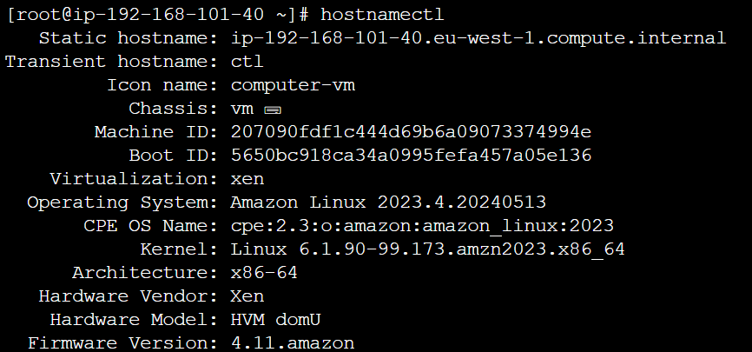

**Target EC2 Instance:**

**Instance Type:** t3.large.

**Operating System:** Windows 2022

**Database:** MS SQL 2019 Developer Edition

**Network Configuration:** Within the same VPC as the source instance to reduce latency, with security groups allowing inbound SQL server traffic on port 1433.

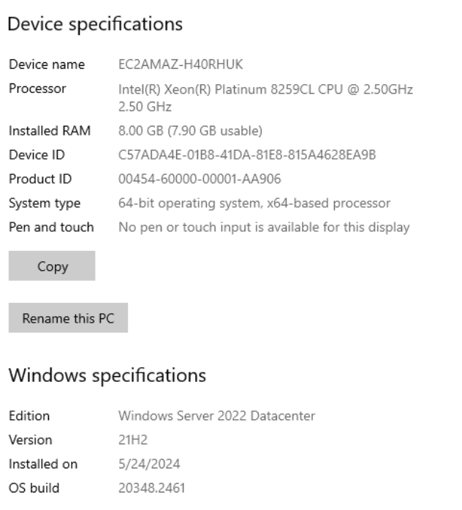

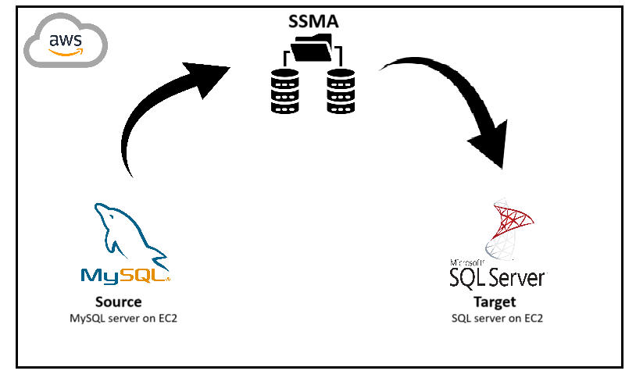

|  |  |
| --- | --- |
| **Source database** | **Target database** |
| MySQL EC2 | MSSQL EC2 |
|  |  |

# Migrations Steps

By using SSMA for MySQL, we can review database objects and data and assess databases for migration.

**Step 1:** Create a new project and select migration target as SQL server.

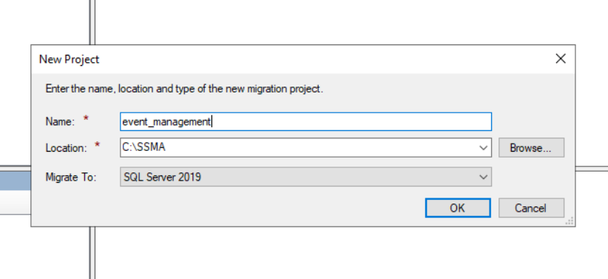

**Step 2**: **Connect to MySQL** dialog box, enter connection details, and then connect to your MySQL server.

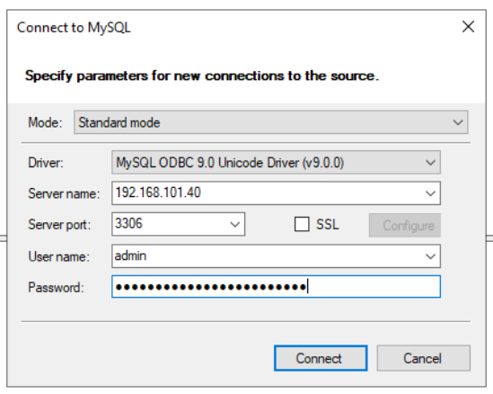

**Step 3:** Select the MySQL databases we want to migrate.

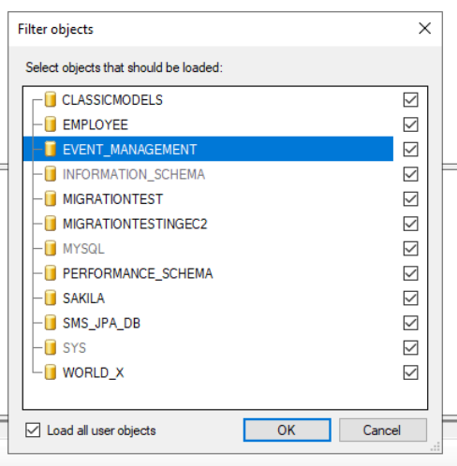

Make sure Default schema mapping in project settings is set to **Database to Database**.

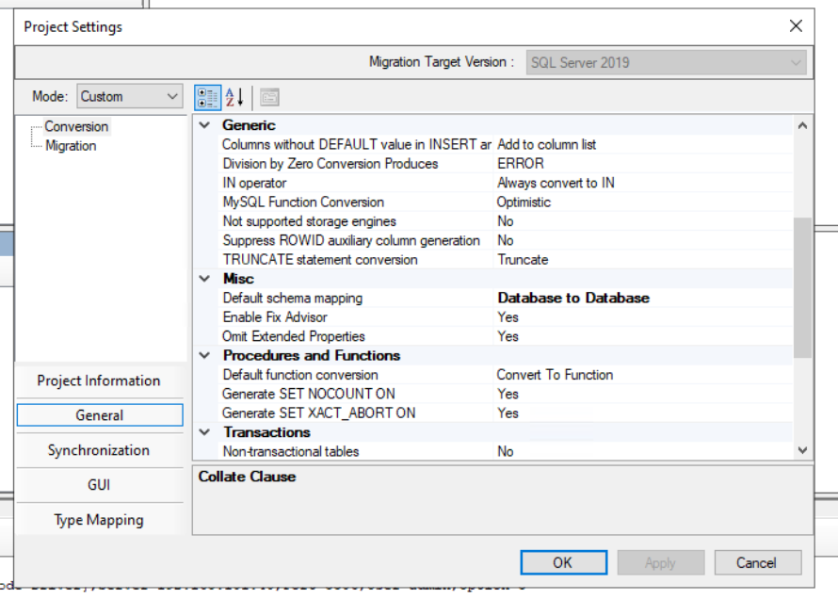

**Step 4:**

Right-click the MySQL database in **MySQL Metadata Explorer**, and select **Create Report**. Alternatively, you can select the **Create Report** tab in the upper-right corner.

Review the HTML report to understand conversion statistics and any errors or warnings.

**Step 5:**

**Connect to SQL Server** tab.

1. Enter connection details for your SQL Server instance.
2. Select your target database from the dropdown list, or enter a new name, in which case a database will be created on the target server.
3. Enter authentication details, and then select **Connect**.

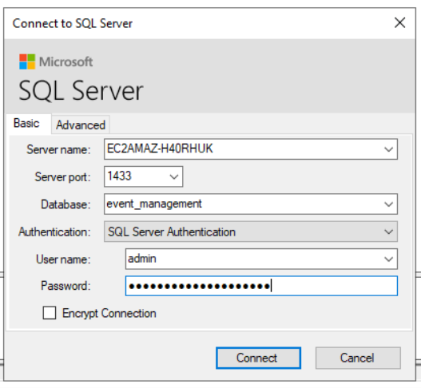

Before migration the schema event_management does not exist in the server.

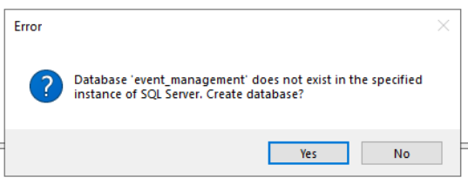

Now the schema is created, database objects are yet to be migrated.

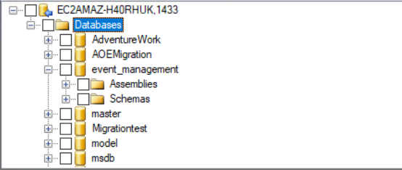

**Step 6:**

Right-click the MySQL database in **MySQL Metadata Explorer**, and then select **Convert Schema**. Alternatively, you can select the **Convert Schema** tab in upper-right corner.

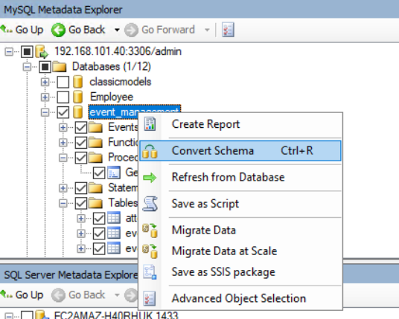

After the conversion finishes, compare and review the converted objects to the original objects to identify potential problems and address them based on the recommendations.

**Step 7:**

Publish the schema by right-clicking the database in **SQL Server Metadata Explorer** and selecting **Synchronize with Database**. This action publishes the MySQL database to the SQL Server instance.

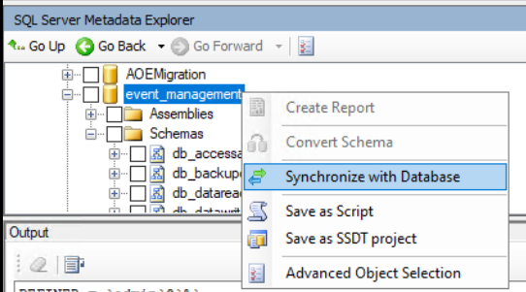

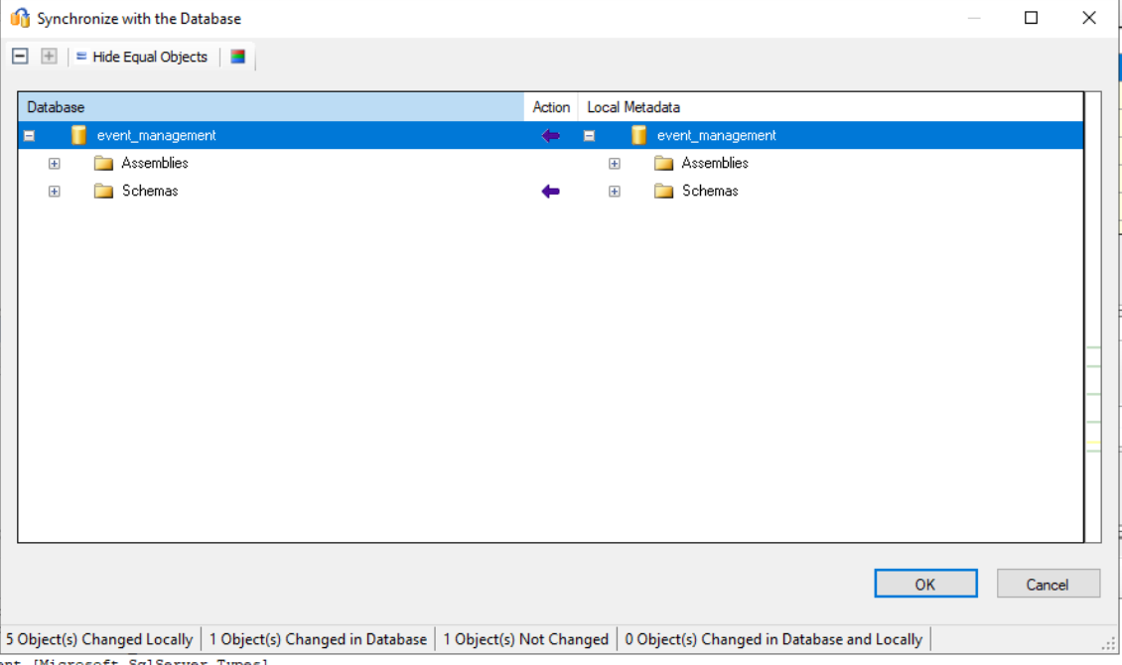

**Step 8:**

Migrate the data by right-clicking the database that we want to migrate in MySQL Metadata Explorer and selecting Migrate Data.

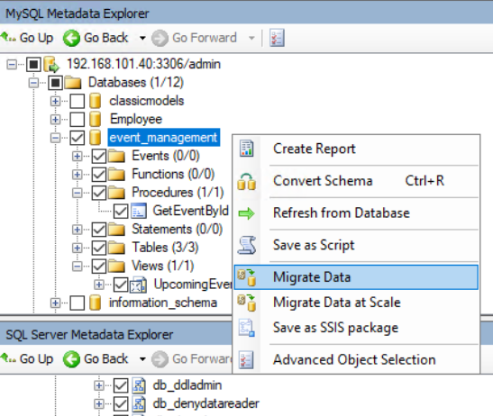

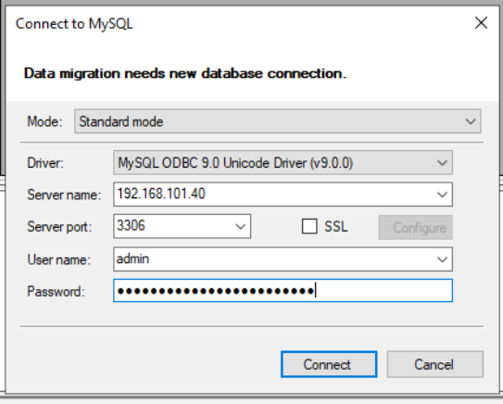Enter authentication details, and then select **Connect**



Save the report

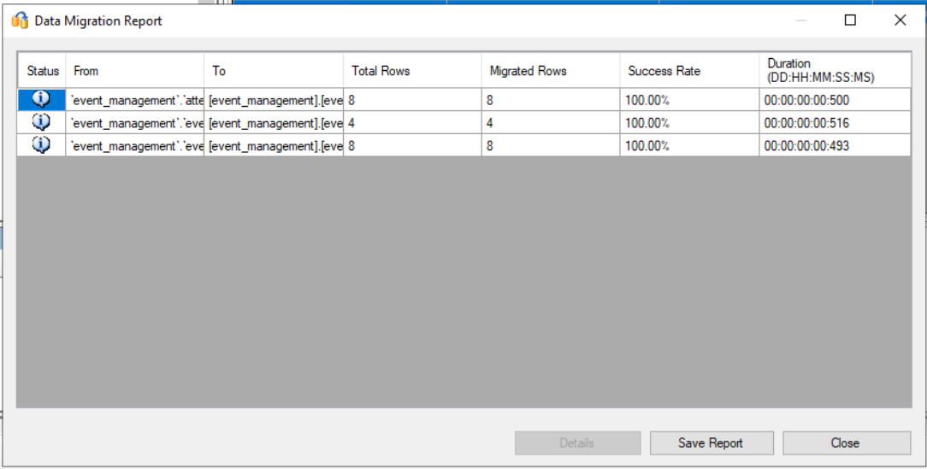

**Step 9:**

Connect to your SQL Server instance by using [SQL Server Management Studio](https://learn.microsoft.com/en-us/sql/ssms/download-sql-server-management-studio-ssms?view=sql-server-ver16) (SSMS), and validate the migration by reviewing the data and schema.

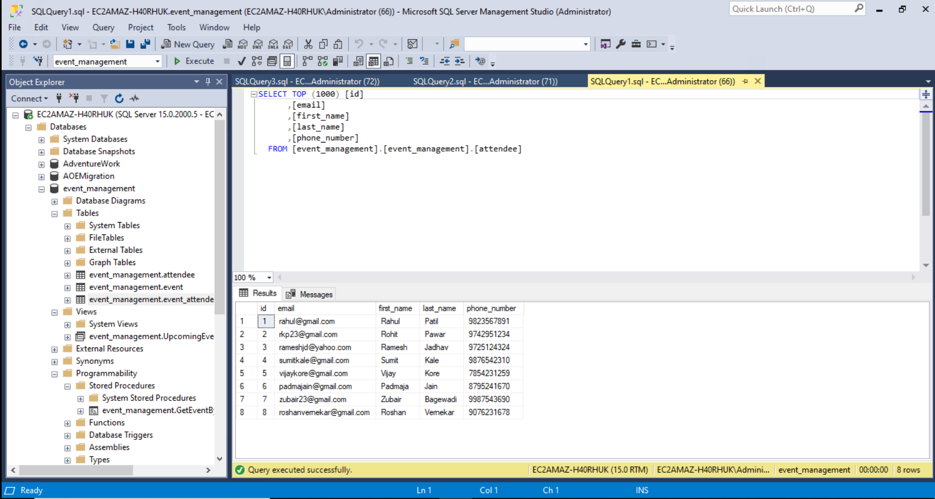

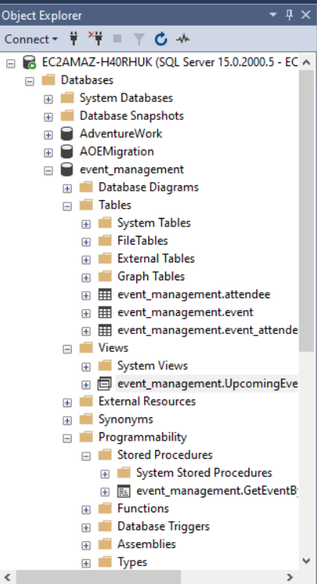

# Connecting the database to a Full stack application

The Event management system application is built with Spring boot backend and React frontend. The backend handles API requests, while the frontend provides a user interface to manage events and attendees.

**Prerequisites:**

* Java 17
* Node.js
* MySQL/SQL database
* Maven(for building the Spring boot application)

**Backend Configuration file for connecting to MySQL server.**

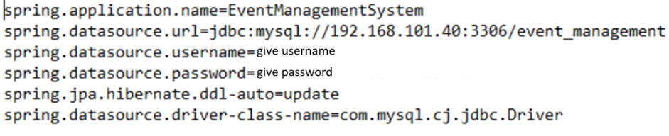

**MySQL database:**

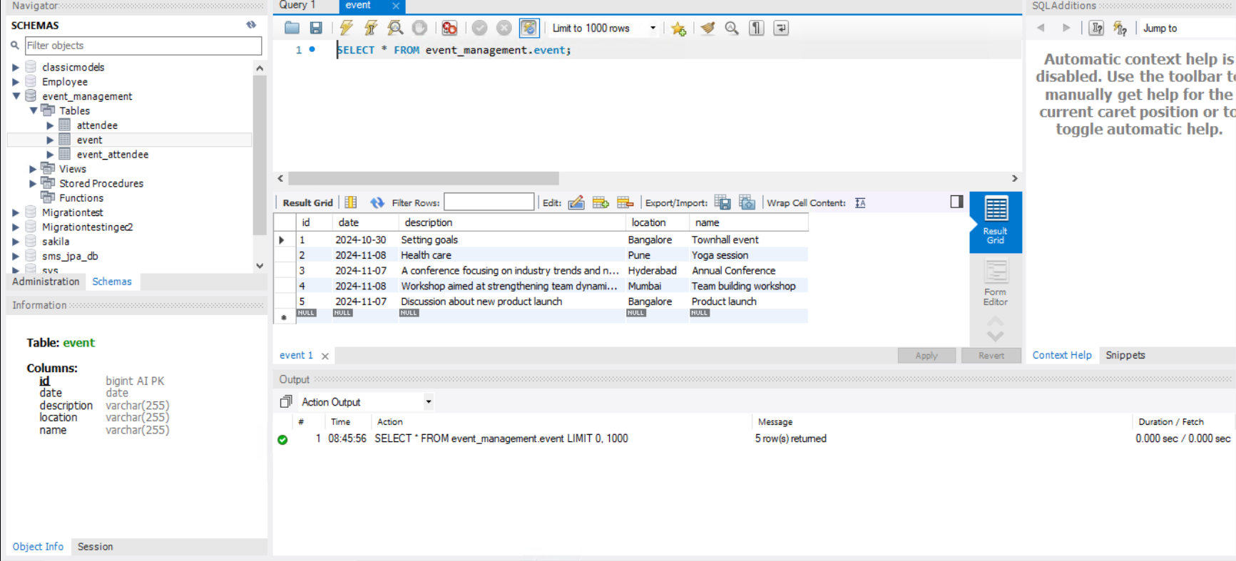

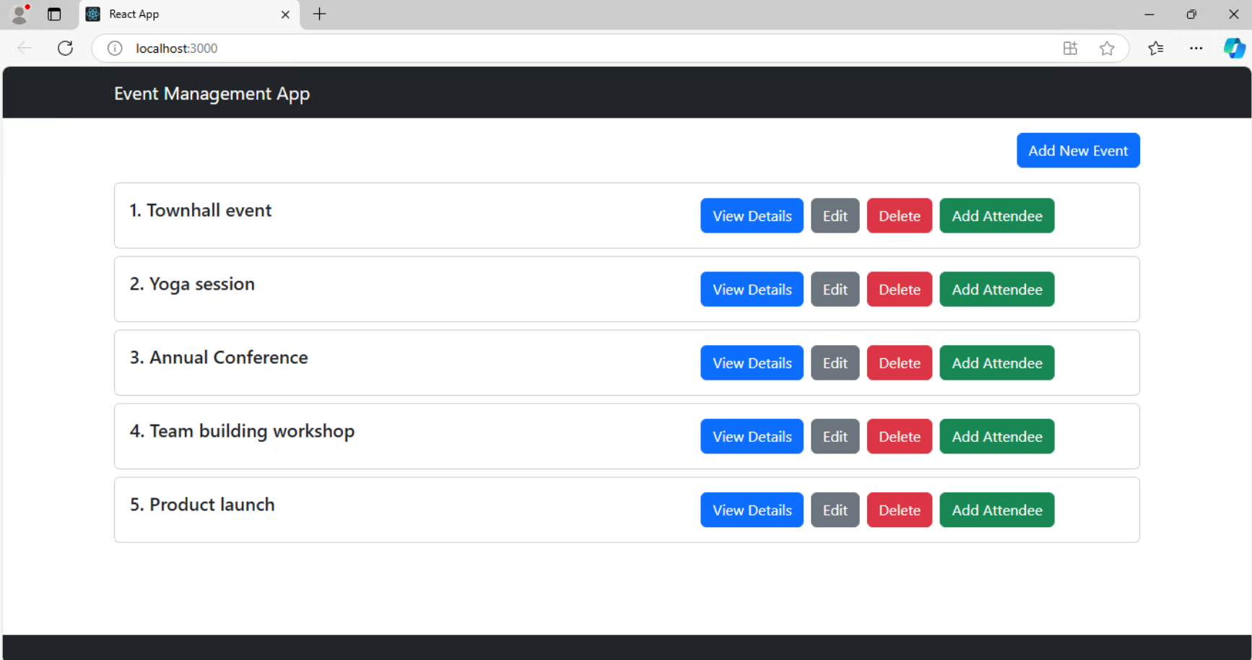

**Functionality of the application:**

1. **User can Add new event and attendees to the respective event.**

1. **User can view Event Details**

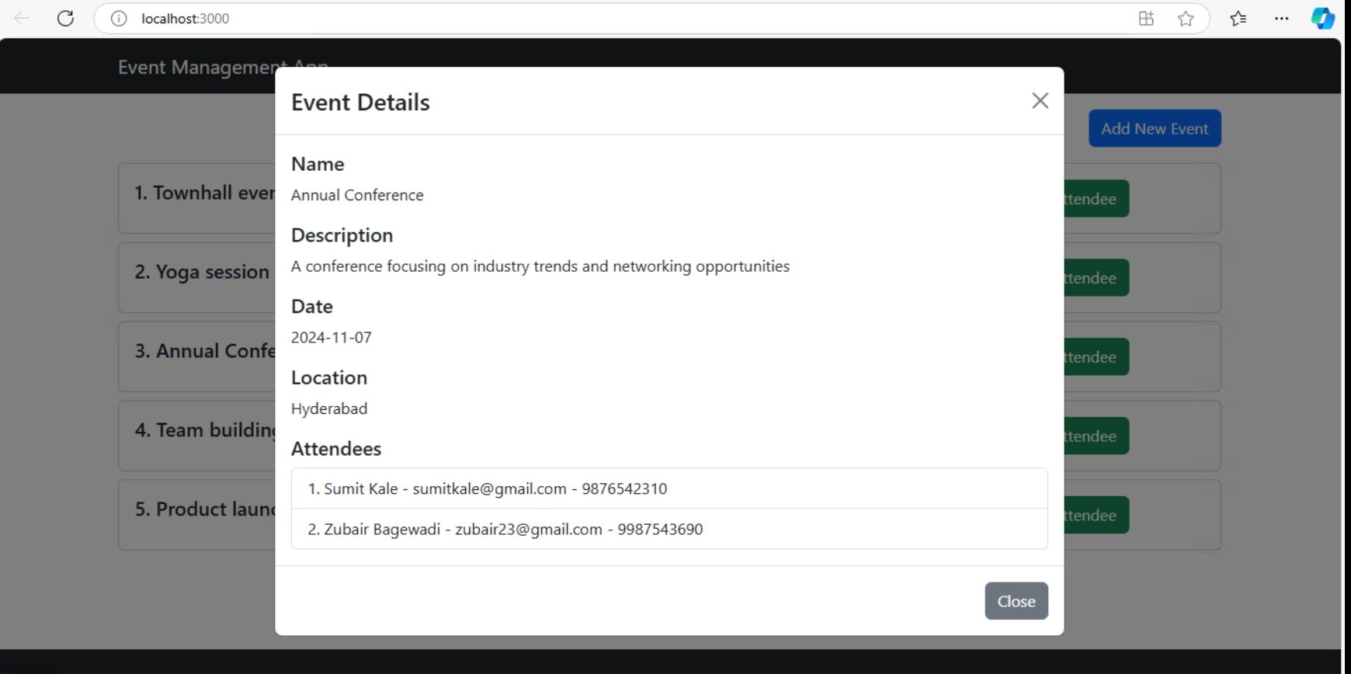

1. **User can update Event Details**

1. **User can Delete Event Details**



**Backend Configuration file for connecting to SQL server.**

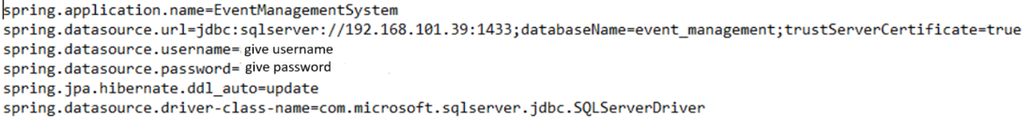

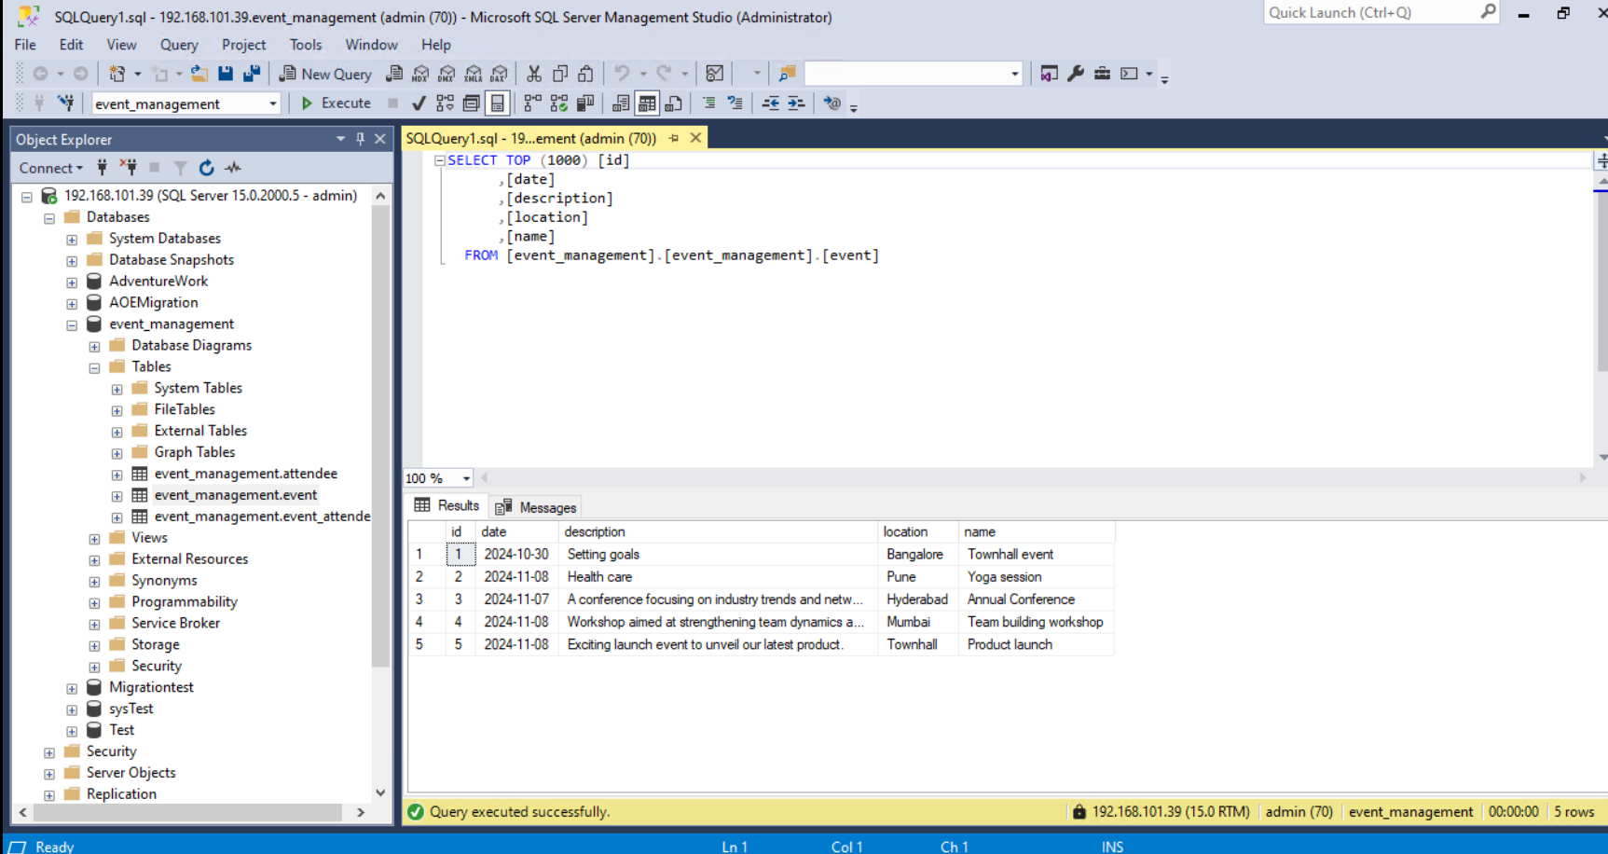

**Running the application:**

Spring boot backend

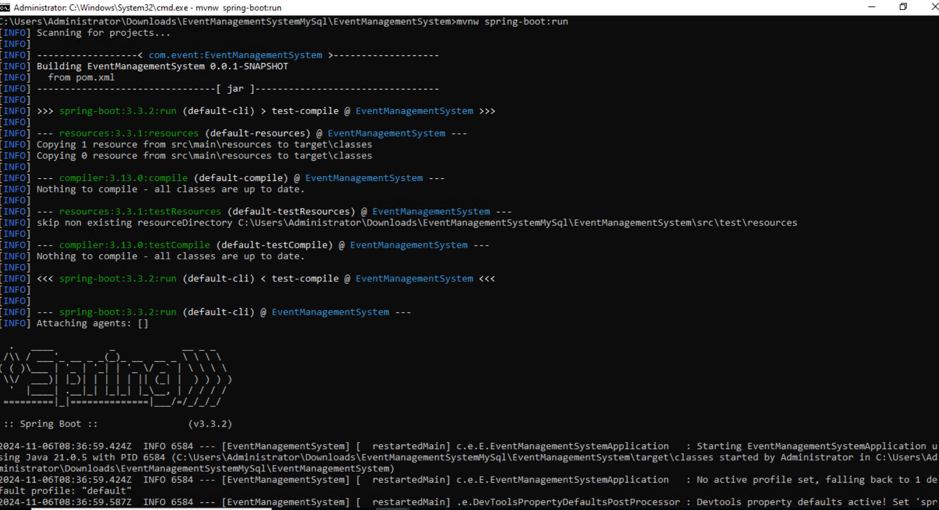

React front end

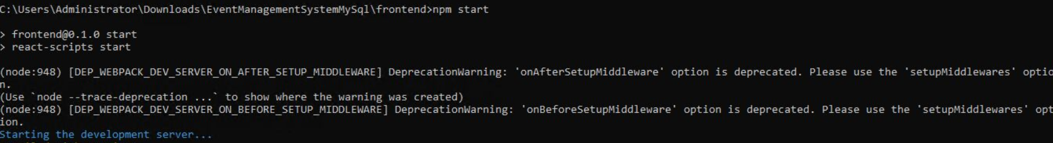

# References

* <https://learn.microsoft.com/en-us/sql/sql-server/migrate/guides/mysql-to-sql-server?view=sql-server-ver16>

# AOE Contacts

|  |  |  |
| --- | --- | --- |
| AOE | Role / Specialist | Email |
| Tushar Shilimkar | AWS Operation  MySQL | [tushar.shilimkar@volkswagen.co.in](mailto:tushar.shilimkar@volkswagen.co.in) |
| Subrahmanya Chaitanya | MSSQL  MySQL | [bommakanti.subrahmanya.chaitanya@volkswagen.co.in](mailto:bommakanti.subrahmanya.chaitanya@volkswagen.co.in) |
| Rohit Pawar | Java and MySQL | [rohit.pawar@volkswagen.co.in](https://volkswagengroup.sharepoint.com/sites/AOE-DBMigrations/Shared%20Documents/General/rohit.pawar@volkswagen.co.in) |
| Jayabal Ananthakrishnan | Consultant and coordinator | [jayabal.ananthakrishnan@volkswagen.co.in](mailto:jayabal.ananthakrishnan@volkswagen.co.in) |